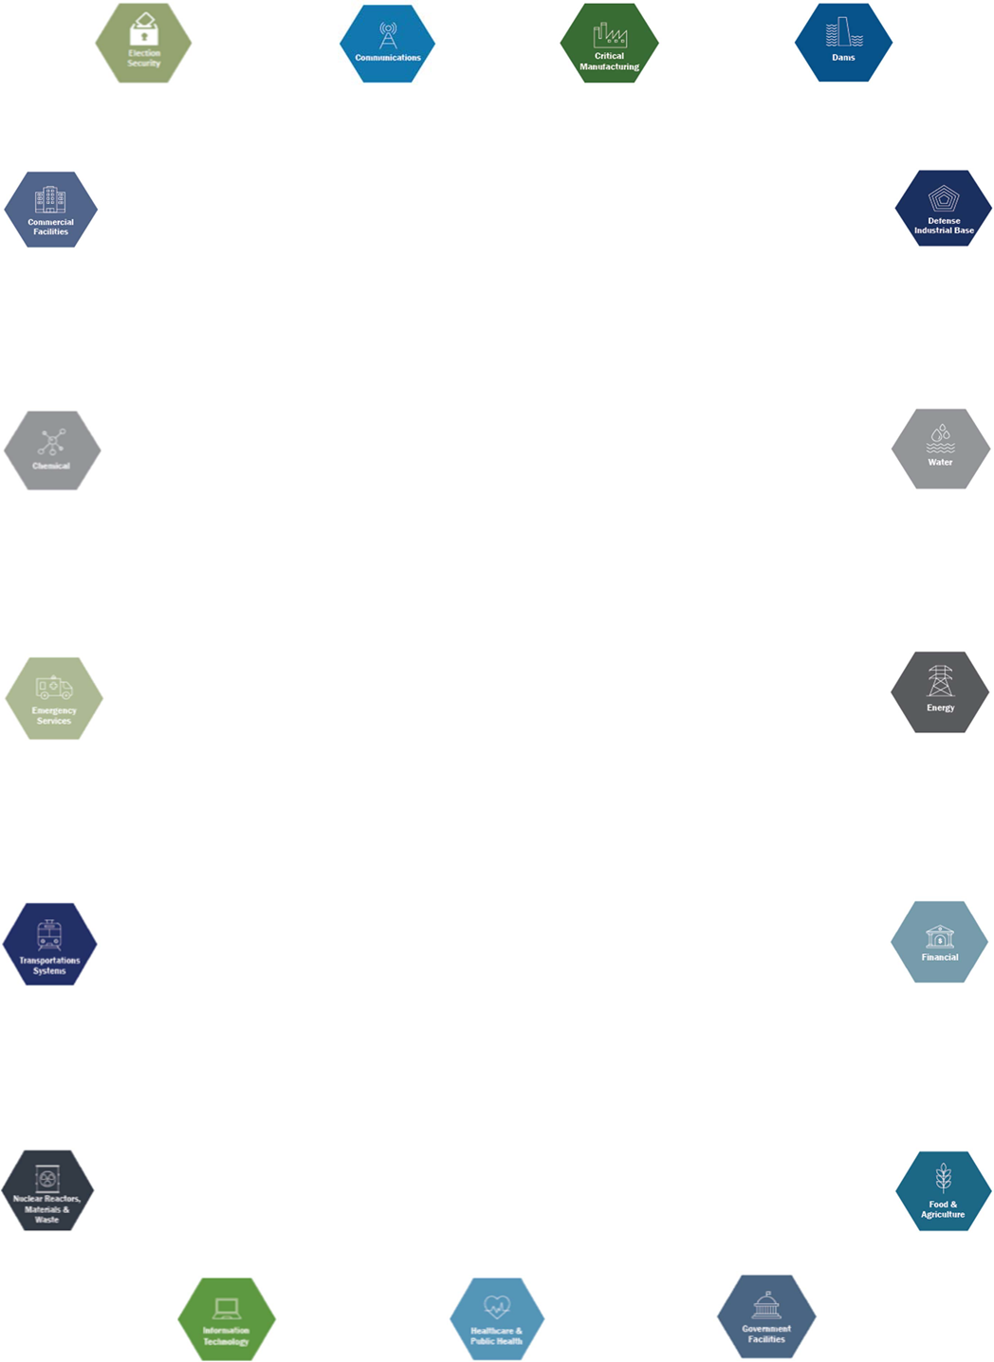
IAEM
CRITICAL INFRASTRUCTURE & BUSINESS CONTINUITY CAUCUS (CI & BC)
MEMBERSHIP APPLICATION
Name:
Business Phone:
Business Email:
Personal Email:
Cell Phone:
Alternate Contact Information:
Preferred Contact Method: | Choose an item.
Industry Sector: | Choose an item.
Employer:
Years in EM/BC:
Do you hold any industry Certifications? | Choose an item.  Other:
If you are a member of other IAEM caucus, please list
Would you attend quarterly virtual meetings? (Regular attendance and contribution are expected) | ☐
What contribution(s) do you anticipate being able to provide? (Be Specific)
Date submitted | Click here to enter a date.
The application is used for recordkeeping only and will not be shared with Caucus Members. Please send your completed application to IAEMCIBC@iaem.com.
For Caucus use Received date:

