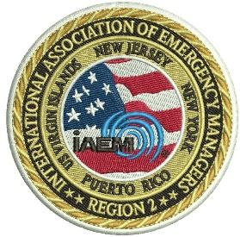

International Association of Emergency Managers
Region 2
and
Stony Brook University
Division of Enterprise Risk Management
Educational Conference
GETTING BACK TO ABNORMAL
June 29-30, 2023
SBU Wang Conference Center

SPONSORSHIP OPPORTUNITIES
Diamond  Naming Sponsor | This sponsor will have the opportunity to have their name attached to the conference on all materials  TAKEN  Sponsorship includes a speaking opportunity during a plenary session, the opportunity to include an advertisement in the welcoming package, space for a table in the Vendors’ Area, 4 attendance credentials  and up to 1 table at the dinner  This is an exclusive sponsorship for 1 organization | $10,000.00
Platinum  Dinner  Sponsor | This sponsor will have their name attached to one of the sponsored dinners on June 29th. A representative will be afforded the opportunity to make welcoming remarks at the opening of the dinner.  Sponsorship includes 2 attendance credentials and up to 4 additional dinner invites  There is one dinner sponsorships available | $8,000.00
Gold  Lunch  Sponsor | These sponsors will have their name attached to one of the sponsored lunches. A representative will be afforded the opportunity to make welcoming remarks at the opening of the lunch.  Sponsorship includes 2 attendance credentials and up to 2 additional lunch invites  There are two lunch sponsorships available | $4,000.00
Ruby  Breakfast  Sponsor | These sponsors will have their name attached to one of the sponsored breakfasts. A representative will be afforded the opportunity to make welcoming remarks at the opening of the breakfast.  TAKEN  Sponsorship includes 2 attendance credentials  There are two breakfast sponsorships available | $2,000.00
Pearl  Break  Sponsor | These sponsors will have their name attached to one of the sponsored afternoon breaks.  Sponsorship includes a vendor space  There are two break sponsorships available | $1,500.00
Vendors | These sponsors will be afforded space in the vendor’s area for both days of the conference and the opportunity to include an item in the welcome packet  Sponsorship includes vendor credentials  There are a limited number of vendor sponsorships available | Full Table  $1,000.00  Half Table  $600

All sponsors will be listed in the Conference Program

For information contact the Conference Chair: EMConferenceCommittee@gmail.com

